Locating rare particles or hotspots

Display of hotspots
The basic idea is to threshold a key element image (or a pair of element images) to select pixels containing these key elements. Start by loading "925-Bi-x.dai" from the Demo data. This data-set from Maia Mapper shows a small number of hotspots in the elements Pt, Bi and Pd.
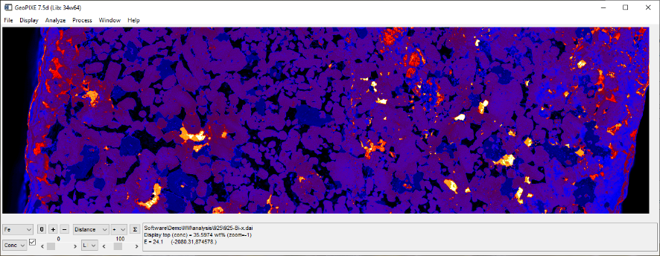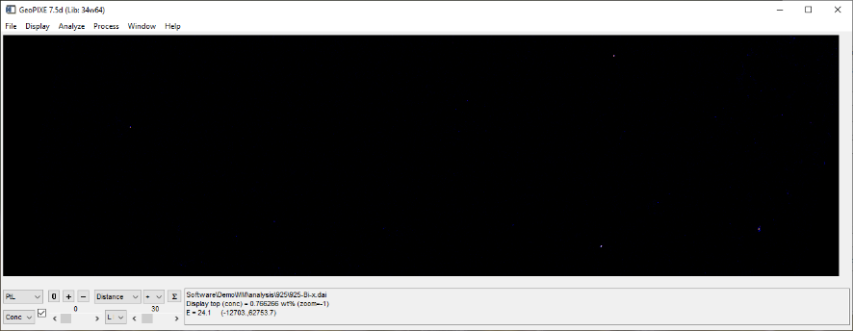
Fe image for scan 925 at zoom=-1 (left), Pt image (right) [click on these to expand, zoom and pan in Confluence]
In GeoPIXE, you can set the zoom level for image display using the "+" (zoom in/ expand), "-" (zoom out, shrink) and "0" (display at full resolution, with one data pixel equal to one screen pixel) buttons. The RGB Image window ("window-->3 Element RGB Images" menu) can be used to display 3 elements in RGB with similar zoom controls. The minimum and maximum pixel concentrations for elements, that map onto the colour map displayed, are controlled using the two sliders on the Image window. These changes are reflected on the RGB Image window. A mixed Pt+Bi hotspots is shown below as yellow.
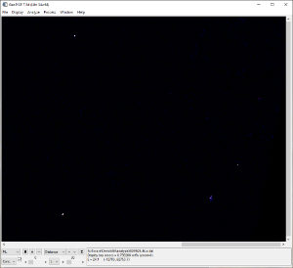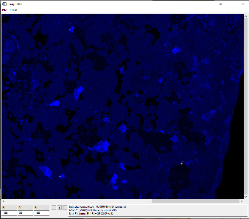
Right end of Pt image at full resolution (zoom = 0, left), RGB image of Bi=red, Pt=green, Fe=blue of same area (zoom = 0, right)

Finding hotspot pixels by Thresholding
These images can be thresholded, or relationships between elements explored, using the Associations window. After selecting a field in 2-element space (click and drag to form a circular area, and then click and drag control points on spline), use the menu "Analyze-->Within Spline" to highlight all pixels with composition within this field.
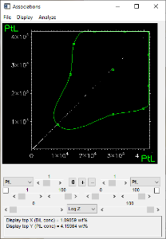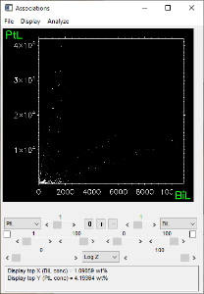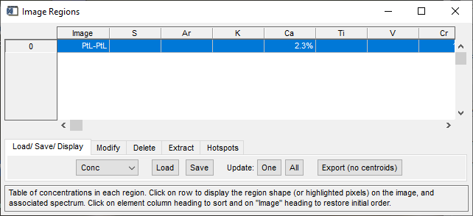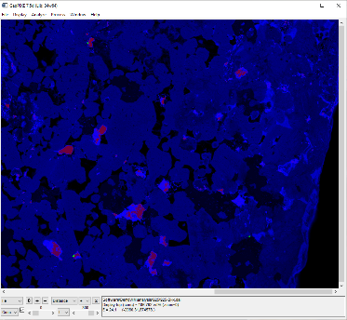
Associations with a Pt threshold set at ~1 wt% apparent (left) and Pt-Bi Association showing trends of contrasting Pt/Bi (centre), Image Region window after Pt threshold, Fe showing selected pixels (right)
The hotspots in this pixel selection can be separated into individual regions, one for each particle or hotspot, using a watershed analysis. Click on the "Hotspots" tab in the Image Regions window to view hotspot operations and enter "Pt" in the text box to use the XY centroids determined from the Pt analyses. Click "Hotspot separation" to calculate these (another popup will warn of the total number found; note that numbers larger than 1000 will take some time).
The first region #0 remains as before, with all hotspots selected. Regions #1 and above are the separated hotspot regions. Remember to save the regions found to a file. The hotspot operation will suggest a suitable file-name.
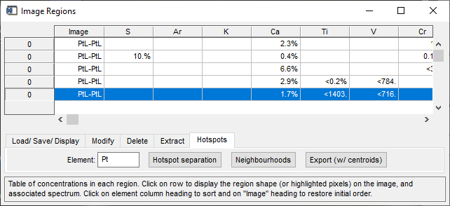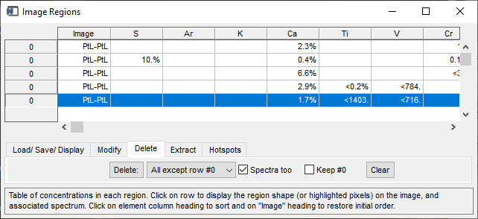
Hotspot Operations tab on Image Regions window after Pt hotspot analysis (left) and the Delete tab (right)
If you need to repeat this hotspot separation, delete all but the first region to start again. Use the button "Delete" on the "Delete" tab after selecting "All regions except #0" on the droplist.

Further refining Association selections to reject more
Start with a spline region on the Association window and do “Analyze-->Include points within Spline” menu. Now enable little checkbox in the middle down near the Z scale type (near “Log Z”) … It shows the pixels selected in last “Analyze” in green.
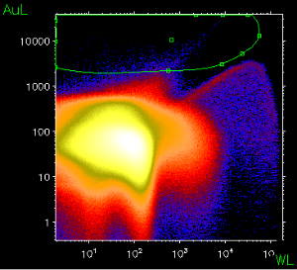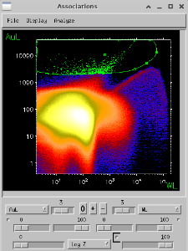
Now switch to display Au-Bi. The same pixels are still coloured green … You can see some points not green in the middle trend, which must be the W ones …
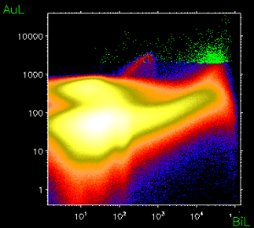
Now, if you want to apply a spline filter again, you can. For example, if we didn’t want high As points (not really there in this sample), then you could apply a second field on Au-As and use the menu “Analyze --> Further refine within Spline” …
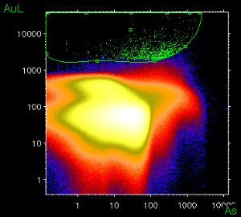

Extraction of spectra from hotspots
Once the hotspot regions have been saved, select "Array" from the drop-list next to the "Extract spectra" button on the "Extract" tab and then click on Extract spectra to sort for all events within each region. These will appear in the Spectrum Display window. Click on a row in the Image Regions window to see its corresponding spectrum in the Spectrum Display window. Mark the lines for Pt using the X-ray Identification window (click on "?" below the spectrum).
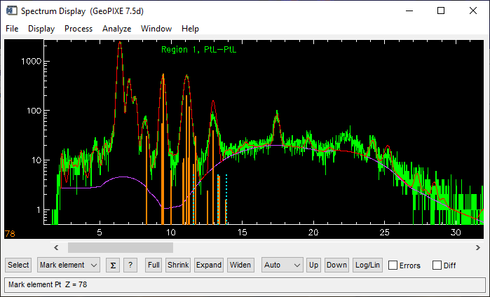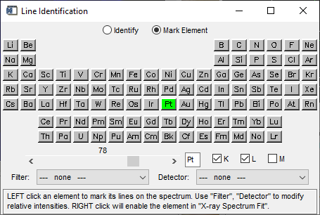
Spectrum for region #1 (left) with Pt lines marked, X-ray Identification window, selecting Pt lines (right)

Searching for and evaluating artefacts
Once you have extracted spectra, you can click on a row in the Image Region table and see the matching spectrum, with an overlay of the DA "fit" to the spectrum based on the DA matrix used for the Image projection. Use the Identify window to mark the lines of an important element (e.g. Pt in this example). To aid in this process, especially for large regions tables, sort the table to put intense elements, that may cause residual overlap artefacts, at the top of the table. Do this by clicking on the element column heading, which will sort the table ordering this element from most intense at the top.
If you sort on likely interference elements, then click on the top rows of the table to see the most likely cases for artefacts. You can delete bad ones on the "Delete" tab selecting "Selected row(s)" on the delete mode drop-list. Check "Spectra too" to also delete the matching spectrum for this region.
Alternatively, if you make a note of any rows that are clearly just due to an artefact and contain no Pt (in this example), then these can be deleted after you have finished examining likely rows using the "Popup selection" delete option.

Neighbourhood analysis
Start from the same region (#0 typically) containing all hotspots. If hot spots are still displayed, clear all but region #0 (all hotspots) using the option "Delete: All except #0" on the Delete tab. Then click on "Neighbourhoods" to construct all neighbourhood regions. Remember that region #0 will still contain all hotspots (not neighbourhoods). Remember to save these as a region file (GeoPIXE will suggest a filename indicating the options used). Spectra can be extracted from neighbourhoods in an analogous way to hotspots (see above).

Display output options

Export from Image window
Images can be exported from the Image window as simple images (which may also show superimposed selected "region" pixels in green) using the menu "File-->Export-->Simple Image-->Save image as PNG". More complex output plots can be exported using the menu "File-->Export-->Image Plot-->Current image as JPEG". The plot options popup provides options for display axes and distance legends, their style and placement, and for the display of a region shape, or cropping to the bounds of that shape. Axes labels can be in relative coordinates (mm from bottom-left corner) or in "absolute" stage coordinates.
NOTE: Use the new JPEG export option as the alternative (PNG) generates files 10x larger. The new JPEG uses the highest quality, so there is no need for PNG.
Click on "Preview" to see it plotted on the screen first, then "OK" to output the full JPEG plot to disk.
You can resize the preview window for the exports to not only give you a larger preview window if desired, but also to give you a better aspect ratio for the plots. This same aspect ratio is then used for the final JPEG file outputs. This way you can make them fill out better.
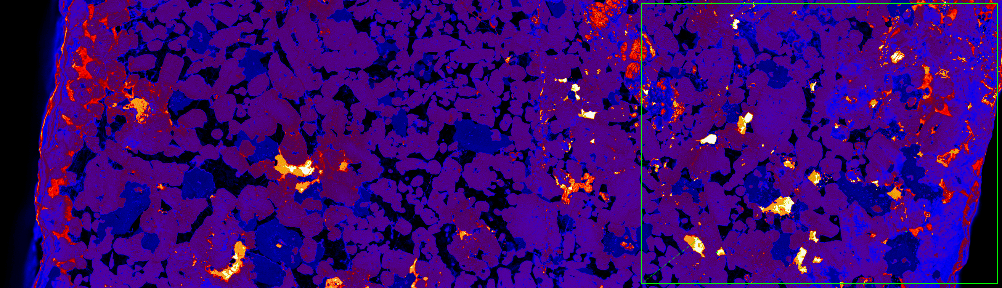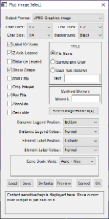
Simple PNG image export showing a region "Box" shape (left), plot export selection popup (right)
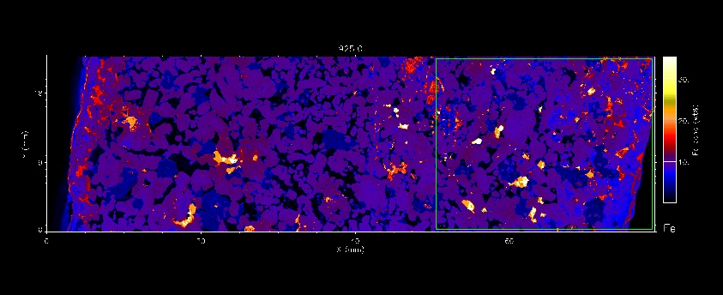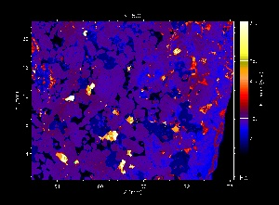
Plot JPEG export of Fe image showing region as "shape" and selected region pixels in green (left), plot JPEG export of Fe cropped to the shape area (right)
The location of hot-spots can be included on the export plot by enabling "Centroids". First, remember to select region #0 before you open the Export Plot window, which shows ALL hot-spots in green on the plot. Then enable "Centroids" and select "Pt" as the "Centroid Element" (must be a single element - will use the centroid X,Y based on this element for each region to position a circle).
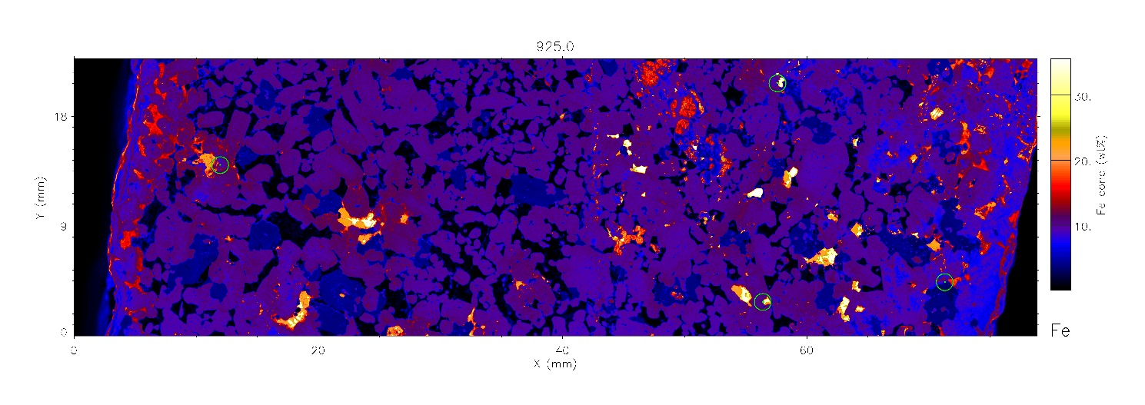
Plot export of Fe on White background, now enabling "Centroids" and selecting centroid Element as "Pt" (now in circles)

Changing the Colour Scheme
The default colour scheme for single element maps can be changed to suit your needs. The linear colour scales such as "B-W Linear" and "Blue/White" can be used to ensure the maps are colourblind friendly.
Change the colour scheme the using the menu "Display-->Colours→Colour Table" and chose a colour table to suit your needs. This will now be the default colour scheme when you open any new files in this session.
The menu "Display-->Colours-->Red Colour Blind-->On" also sets the Blue/White colour map and changes how spectra colour overlays works too.
To export, follow the instructions above in: Export from Image Window.
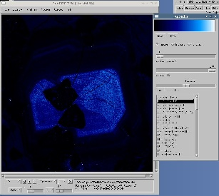

Export from RGB Image window

RGB Images
Any display on the RGB Window can be saved as a simple JPEG file using the menu "File-->Export-->Simple Image-->Save as JPEG" (avoid using the PNG save option, as it makes files ~10x bigger with little visible improvement in quality as we use the highest quality JPEG settings). This will output the RGB image at the current zoom (which may not show all detail). To get all details, go to full scale first (zoom=0, using "0" button).
Better still, use the RGB "Learn" feature to learn all the RGB images you want output, and to do them all automatically, and at full resolution (zoom=0). For the first RGB combination that you want, use the menu "Learn-->Start" to register the first RGB image. For subsequent ones, use menu "Learn-->Next". Finally, save all these using menu "Learn-->Save". Note that a number of these RGB scripts have been saved already in the top-level "analysis" directory (in MapperMel1). To restore one of these, use menu "Learn-->Restore". Note that no images have been output yet. To output all images at a selected zoom (defaults to full scale, zoom=0), use the menu "Learn-->Execute".
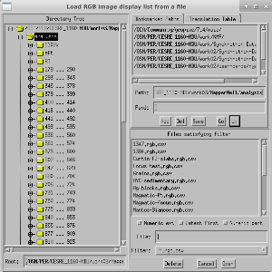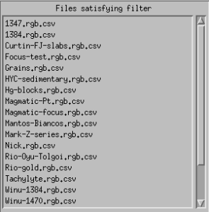
Note that the Learn RGB CSV files are simple text files and can be edited.

RGB Image plots
The RGB image window has similar export options to the Image window plots. Best to use the menu "File-->Export-->Image Plot-->Current image as JPEG" (avoid using the PNG save option, as it makes files ~10x bigger with little visible improvement in quality as we use the highest quality JPEG settings).
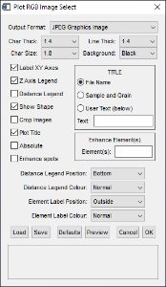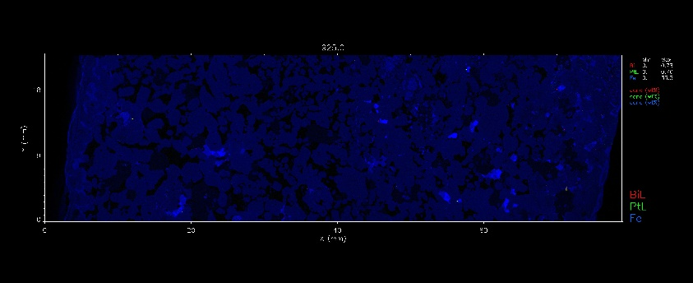
Plot JPEG options popup (left) and Bi Pt Fe RGB image export (right)
Click on "Preview" to see it plotted on the screen first, then "OK" to output the full JPEG plot to disk.
You can resize the preview window for the exports to not only give you a larger preview window if desired, but also to give you a better aspect ratio for the plots. This same aspect ratio is then used for the final JPEG file outputs. This way you can make them fill out better.
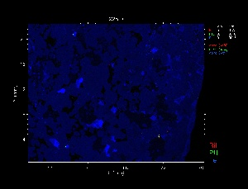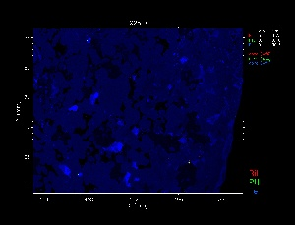
Plot JPEG image export for a cropped region of the Bi Pt Fe RGB image in relative coordinates (left) and absolute stage coordinates (right)

Highlight hotspots on plots
The export can also highlight the location of hotspots using the "Centroids" option for the single element display and the "Enhance" option for the RGB display. "Centroids" will plot a ring around each hotspot. Select the element to use its XY centroid coordinates in the "Centroid element" text field. "Enhance" will use a grey-scale Dilate morphological operator to slightly expand the hotpots so they remain visible on the RGB display or output plot.
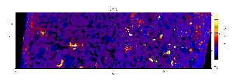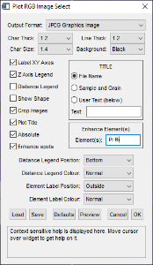

Region table export
Use the Region Operation ("*" button) "Export hot-spots region table with centroids" to export a table of results as a CSV file, which includes the flux, number of pixels and pixel X,Y centroid for each hotspots particle (pX, pY are the scan pixel centroids and rX, rY are the relative scan coordinates [from bottom-left corner]). The pixel centroid in the pixel coordinate in the original scanned image, even if a sub-region has been processed or an output has been cropped to a Box.
Note that a hotspot is likely to be smaller than a pixel, and of finite thickness. Hence, it will show as some smaller "apparent" composition reflecting its size.
# | Image | Cr | Fe | Ni | Cu | Pd | PtL | BiL | Flux | Pixels | pX | pY | rX (mm) | rY (mm)
0 | PtL-PtL | 1345 | 133174 | 5550 | 5271 | 28 | 19809 | 3855 | 378 | 48 | 1751.28 | 317.465 | 52.4208 | 9.41124
1 | PtL-PtL | 1992 | 188795 | 12619 | 1961 | 28 | 24516 | 1010 | 142 | 18 | 1879.92 | 93.118 | 56.3973 | 2.79339
2 | PtL-PtL | 512 | 70828 | 1400 | 11251 | 48 | 12744 | 10561 | 70.9 | 9 | 2376.11 | 147.56 | 71.2833 | 4.42764
3 | PtL-PtL | 364 | 69788 | 1114 | 283 | 41 | 14246 | 5752 | 70.9 | 9 | 399.148 | 466.865 | 11.9752 | 14.0059
4 | PtL-PtL | 1735 | 144043 | 1387 | 9490 | 2 | 22220 | 1671 | 94.6 | 12 | 1919.81 | 690.01 | 57.5943 | 20.7009
All element results are shown as ppm apparent (for the model composition and typically 30 µm pixel size)

